Design and Simulation of a Critical Conduction Mode Boost Converter for Power Factor Correction
Author: Priyanshu Ranjan
Department: Electrical and Electronics Engineering
Affiliation: BIT Mesra

Abstract
This paper presents the design, modeling, and simulation of a single-phase AC–DC boost converter operating in Critical Conduction Mode (CRM) for Power Factor Correction (PFC). The objective is to shape the input current to follow the input voltage, thereby achieving a high power factor while regulating a constant DC output voltage. A peak current–mode control strategy with zero-current detection is employed to ensure CRM operation, enabling zero-current turn-on and reduced switching losses. The system is implemented and verified using MATLAB/Simulink. Simulation results demonstrate near-sinusoidal input current, regulated output voltage, and improved power factor. Ripple behavior inherent to CRM operation is analyzed and quantified using ripple factor calculations.
Index Terms— Power factor correction, boost converter, critical conduction mode, boundary conduction mode, peak current control.

I. Introduction
Modern power electronic equipment connected to single-phase AC mains, such as switch-mode power supplies, LED drivers, and battery chargers, typically employ diode-bridge rectifiers followed by bulk capacitors. While simple, this configuration draws highly distorted input current, resulting in poor power factor (PF) and high total harmonic distortion (THD). International standards mandate improved input current quality, motivating the use of active Power Factor Correction (PFC) techniques.
Among various topologies, the boost converter is widely adopted for single-phase PFC due to its ability to produce an output voltage higher than the peak input voltage and to draw a controllable input current. This work focuses on a boost PFC operating in Critical Conduction Mode (CRM), also known as Boundary Conduction Mode (BCM), which provides an optimal trade-off between efficiency and control complexity for low-to-medium power applications.

II. System Configuration
The proposed system consists of the following main stages: 1. Single-phase AC source and diode bridge rectifier 2. Boost power stage (inductor, MOSFET, diode, output capacitor, and load) 3. Voltage control loop (outer loop) 4. Current control loop with zero-current detection (inner loop)
The rectified input voltage is sensed and used to generate a sinusoidal current reference. The control system ensures that the inductor current follows this reference while the output voltage is regulated to a fixed DC level.

III. Operating Principle of CRM Boost PFC

A. Boost Converter Operation
When the switch is turned ON, the inductor stores energy from the input source. When the switch is turned OFF, the stored energy is transferred to the output through the diode, raising the output voltage above the input level.

B. Critical Conduction Mode
In CRM operation, the inductor current starts from zero at the beginning of each switching cycle, increases linearly to a peak value, and then decreases back to zero before the next cycle begins. The switch is turned ON exactly when the inductor current reaches zero. This results in: - Zero-current switching (ZCS) at turn-on - Reduced switching and diode reverse recovery losses - Variable switching frequency dependent on input voltage and load

IV. Control Strategy

A. Voltage Control Loop
The output voltage is compared with a reference value (typically around 380–400 V for universal AC input). The error is processed by a PI controller to generate the amplitude of the current reference. This loop operates at a bandwidth much lower than the line frequency.

B. Current Control Loop
The rectified input voltage is multiplied by the output of the voltage controller to generate a sinusoidal current reference. The actual inductor current is compared with this reference using a comparator. An SR latch and zero-current detection logic generate the PWM signal, ensuring CRM operation.
The control objective can be expressed as:
$$i_{L}\left(t\right)∝\left|v_{in}\left(t\right)\right|$$
which ensures unity power factor operation.

V. Simulation Model
The complete system is modeled in MATLAB/Simulink using discrete-time simulation. Power electronic switches and passive components are modeled with non-ideal characteristics to capture realistic behavior. A small simulation time step is chosen to accurately resolve switching transients.
Key measured signals include input voltage, input current, inductor current, output voltage, and calculated power factor.
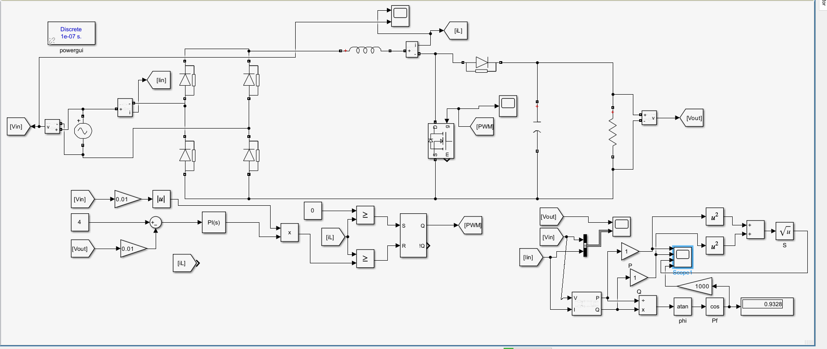
Fig. 1. MATLAB/Simulink model of the single-phase CRM boost PFC converter showing the rectifier stage, boost power stage, voltage control loop, and current control loop with zero-current detection.

VI. Ripple Analysis
Due to CRM operation, the inductor current exhibits a high triangular ripple.
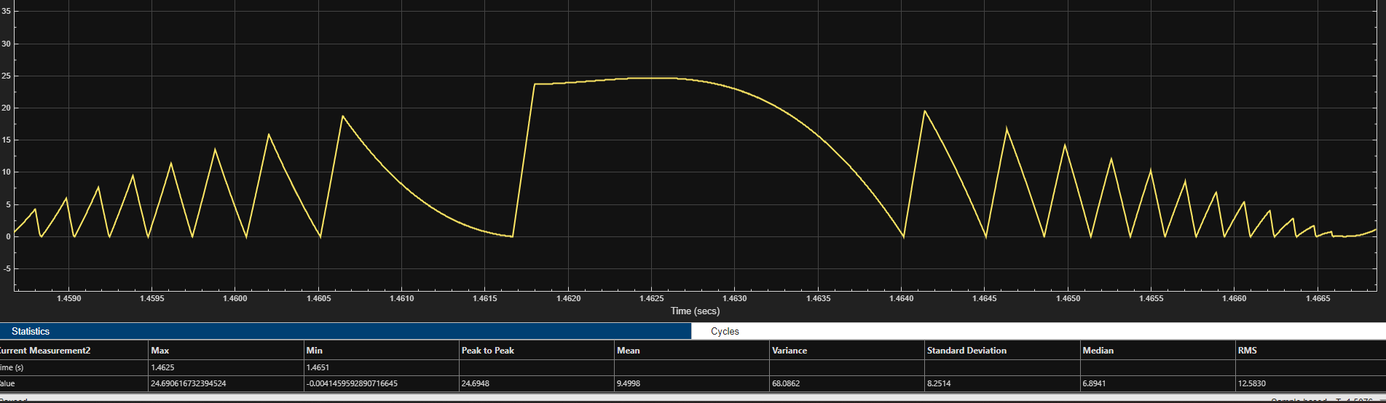Fig. 2. Inductor current waveform in Critical Conduction Mode showing triangular current shape and zero-current intervals at the end of each switching cycle. The ripple factor is calculated to quantify this behavior.

A. Ripple Factor Definition
The ripple factor for current is defined as:
$$r=\frac{I_{\text{ripple,rms}}}{I_{\text{DC}}}$$
where
$$I_{\text{ripple,rms}}=\sqrt{I_{\text{rms}}^{2}-I_{\text{DC}}^{2}}$$

B. Simulation Results
From simulation measurements: - Mean (DC) current, ( I_{DC} = 9.4998 ) - RMS current, ( I_{rms} = 12.5830 )
Thus,
$$I_{\text{ripple,rms}}=\sqrt{{\left(12.5830\right)}^{2}-{\left(9.4998\right)}^{2}}=8.251$$
The ripple factor is:
$$r=\frac{8.251}{9.4998}≈0.87$$
The high ripple factor is inherent to CRM operation and confirms that the inductor current reaches zero every switching cycle, validating correct CRM behavior.

VII. Results and Discussion
Simulation results show: - Near-sinusoidal input current in phase with the input voltage - Regulated DC output voltage with low low-frequency ripple - Power factor close to unity (approximately 0.93) - Zero-current turn-on of the switch
Although the current ripple is high, it does not adversely affect the power factor and is an expected characteristic of CRM PFC converters.
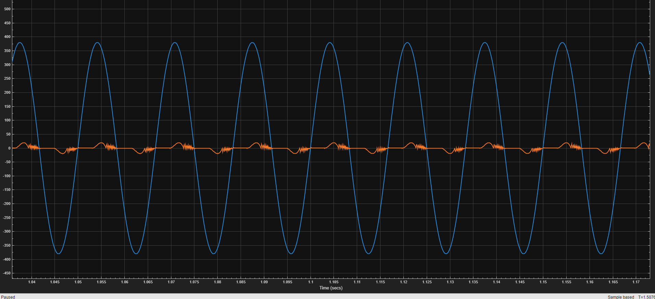Fig. 3. Input voltage and input current waveforms demonstrating near-sinusoidal current shaping and near-unity power factor operation.

VIII. Advantages and Limitations

A. Advantages
- High efficiency due to zero-current switching
- Simple current control without slope compensation
- Reduced diode reverse recovery losses
- Suitable for low-to-medium power applications

B. Limitations
- Variable switching frequency complicates EMI filter design
- Higher peak currents compared to CCM operation
- Not suitable for very high power levels

IX. Possible Improvements and Future Work
Future enhancements may include: - Interleaved CRM PFC to reduce current ripple - Digital control implementation with adaptive tuning - Use of wide-bandgap devices such as SiC or GaN - Hardware prototype development and experimental validation

X. Conclusion
A single-phase boost PFC converter operating in Critical Conduction Mode has been successfully modeled and simulated. The proposed control strategy achieves high power factor, regulated output voltage, and efficient operation with zero-current switching. The results validate the suitability of CRM boost PFC converters for practical low-to-medium power applications.

References
[1] R. Erickson and D. Maksimović, Fundamentals of Power Electronics, 2nd ed. Springer, 2001.
[2] N. Mohan, T. M. Undeland, and W. P. Robbins, Power Electronics: Converters, Applications, and Design, Wiley.
[3] M. K. Kazimierczuk, Pulse-Width Modulated DC–DC Power Converters, Wiley.

